C/o Burcher Gale Grove
North Peckham
LONDON
SE15 6FL

Mr P Rowan M.P
Chair, All Party Parliamentary Light Rail Group
House of Commons
LONDON
SW1A 0AA

17 September 2009

Re: Submission to the All Party Parliamentary Light Rail Group’s Inquiry into Light Rail: The Cross River Tram Experience

Dear Mr Rowen,

I am writing to thank you for the opportunity to contribute to the Parliamentary Light Rail Group’s forthcoming investigation on tram schemes in the UK.

EQRA is confident that your inquiry will play a useful role in highlighting the current barriers to tram scheme development in this country and how these may be overcome.

In so doing, we hope you will be able to provide us with answers as to why our politicians often struggle to bring long promised tram projects to fruition.

In this submission we seek to provide you with an insight into our experiences of one such project, the Cross River Tram (CRT) in London.

If you do require clarification of certain aspects of our submission in the meantime please do not hesitate to get in touch.

Kind Regards,

Phil Bale
Chair, EQRA
North Peckham, London

Cross River Tram Map

Route options as consulted on in 2006/07

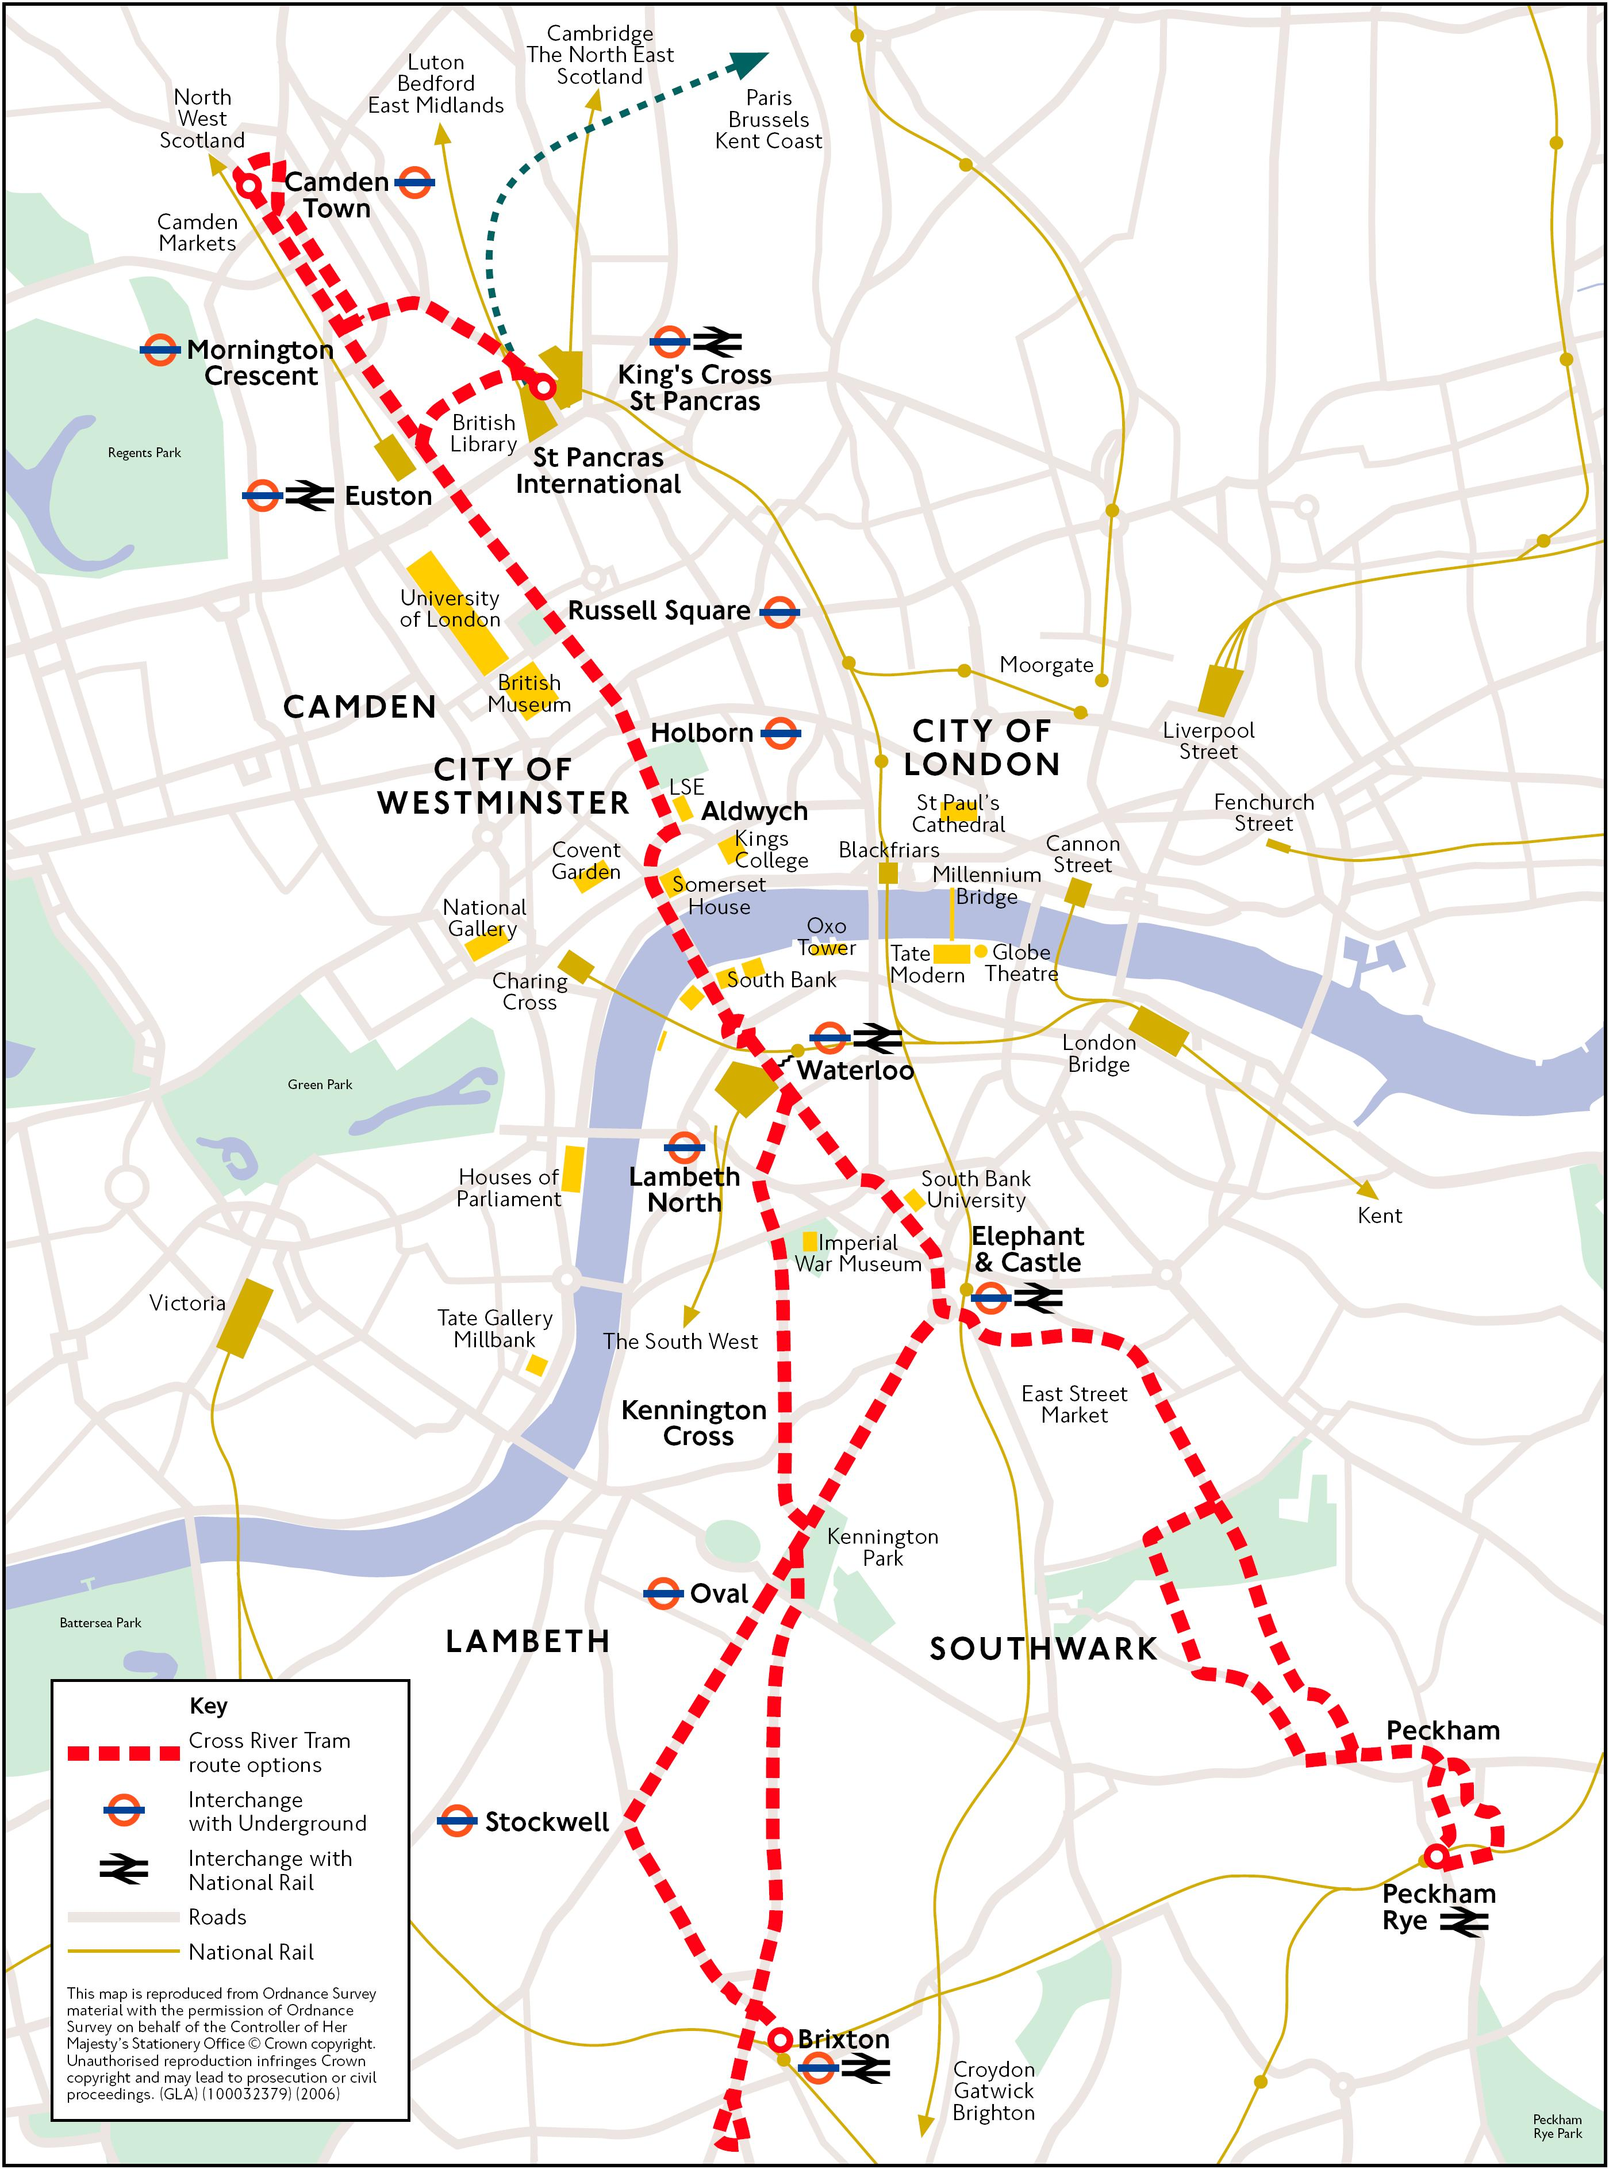

Executive Summary

- The withdrawal of support for the CRT in November 2008, under a newly elected London Mayor, concerns us greatly. The decision is typical of the problems caused by shifting political landscapes on the development and implementation of trams systems in the UK. Such problems only increase as the length and cost of tram scheme development increases.

- The CRT decision has been justified by the Mayor on the basis of a lack of certainty on future funding from Central Government. However, this is often the case for proposed transport projects which can take decades to build up the necessary support.

- Transport for London (TfL) changed its position on the CRT in 2008 and now claims improvements to existing transport modes could deliver some of the benefits of the CRT at a reduced cost. However, none of these alternatives have funding in place either.

- Since doubts emerged over the CRT project, increasing numbers of residents have started to move out of our area to better connected parts of the capital. This is destabilising and undermines past regeneration initiatives, such as the £290m Peckham Partnership programme. Early, effective and ongoing stakeholder dialogue is vital to maintain support and confidence, as well as to limit damage when tram projects do not proceed.

- Faith in the political process has been undermined by the continued failure to deliver the CRT scheme (or communicate on alternatives). Such experiences have now contributed to increased political apathy and cynicism amongst the local electorate.

- Stakeholder engagement from Transport for London on the CRT has been woeful and prior to the cancellation of the project was subject to repeated and prolonged delays. Since work on the CRT scheme was halted in November 2008, residents and businesses along the planned route have had no communication or information from TfL or the Mayor’s Office on why the business case for the tram has changed so drastically.

- Despite the setbacks, our group continues to support the CRT as the mode most able to offer a direct, frequent and eco-friendly form of transport through some of the most deprived parts of London. The tram would open up our community, dispelling widely held negative perceptions and would act as the missing catalyst for new investment.

Recommendations

- There is a need to better harness grassroots and NGO support for tram projects to help schemes reach fruition.

- Tram projects would be substantially strengthened through the early identification of key stakeholder representatives (inc. resident and community groups) and their involvement in a forum which promoted greater awareness, co-ordination of effort and joint working.

- More comprehensive communication strategies would have benefited the CRT and complemented the consultation and planning processes. There was no internet supporters group for the CRT and no obvious avenue for people to offer their continued support.

- Consultation needs to be proportionate as many of our residents believe the CRT route options process to have been unnecessarily drawn out.

- Information supplied to us by TfL suggests that light rail concessions are treated more toughly in the UK against rules in the Eurozone. However, only the Government and the Office for National Statistics would be able to change this policy. If this is the case, EQRA would welcome any legislative or rule changes which could aid the efficient development of more tram schemes in the future. (APPENDIX B)

Cross River Tram: Community Perspectives

1 Shifting Political Landscapes

  - Peckham would be one of the main beneficiaries of the proposed Cross River Tram project in London. During the turn of the century a major regeneration programme supported the investment of £290m in new housing and amenities. Yet despite this, local challenges remain and the area has struggled to find a new identity and purpose. Public transport inaccessibility is a large part of the problem and acts as one of the main supporting pillars which any community requires in order to be a success. CRT was the long trailed solution and from its inception has enjoyed significant levels of cross party, business and resident support in Southwark, yet even this has not been enough to see the project through to fruition.

  - In 2002 Transport for London (TfL) announced its intention to move forward with the Cross River Tram, it being their preferred long term solution to the public transport deficit in our community. Since that decision the costs of the scheme has been constantly revised and the latest figures place put at £1.3bn. (APPENDIX A)

  - Following the election of a new London Mayor a Major Projects Review commenced within TfL. This review resulted in an announcement in November 2008 that the CRT would no longer be taken forward due to constraints on its funding. The Mayor adding that the scheme had “much merit”. The withdrawal of support under the new Mayor, on the pretext of future funding uncertainties, concerns us greatly and highlights the impact of politics and politicians on planning new tram schemes. EQRA contacted all the Mayoral candidates during last year’s election contest and all offered varying degrees of support for the project.

  - It also raises concerns of a potential bias against light rail within TfL and/or the Mayor’s office. This is because justification for cancelling further work on the CRT was given as a lack of certainty in securing future funding from Government. TfL also state that since their initial adoption of the CRT, other schemes may be able to deliver some of the benefits of the CRT at a reduced cost instead. Yet none of these alternatives have any funding secured either!

  - In a previous submission to the London Assembly’s Transport Committee Seminar on the Cross River Tram, we highlighted some of the most important project benefits, including greater tourist potential, improved mobility/accessibility of public transport, higher inward investment, reduced crime and improved employment & training prospects.

  - Instead we are now faced with a real possibility that transport improvements elsewhere in the capital will not only place parts of the tram route at a competitive disadvantage, but may also lead to established businesses relocating to benefit from such investments. There is a risk that the market for jobs and investment within London is in effect being skewed away from boroughs such as Southwark.

- Community Impacts

  - Significant numbers of new residents were attracted to north Peckham on the understanding that public transport would be improved by a new tram network. Since doubts have emerged around the CRT project, increasing numbers of owner occupiers have began to move out of the area to better connected parts of the capital. This is destabilising our community and undermines past regeneration initiatives such as the £290m Peckham Partnership programme.

  - Attracting and retaining long term residents to an area is central to helping support a more balanced community. The uncertainty over the CRT has seen residents sell (or rent) their homes. This has led to a higher percentage of tenants, who often have shorter time horizons, and are consequently much less interested in community involvement.

  - EQRA therefore have real concerns that uncertainty over the CRT (caused by funding uncertainties and a long planning process) has contributed to higher levels of turnover amongst the local population. This will inevitably make it much harder for resident groups like us to develop and remain sustainable. Local Authority and Housing Association tenants often do not have such options.

  - The CRT would encourage more people to stay in our area, reducing resident turnover, and attracting a good mix of long term residents who have a shared interest in developing a strong sense of community.

  - The continued uncertainty over the CRT inevitably erodes confidence in management of such schemes, increasing the prospects of pubic opinion turning against a project.

  - Faith in the political process has also been undermined by the failure to deliver the scheme. This has increased political apathy and cynicism amongst the local electorate.

  - The CRT was incorporated into a long term planning document, the Peckham Area Action Plan, underpinning other planned investment decisions. It also formed a key part of the marketing for local businesses through the work of the Peckham Town Centre Management Group (PTCMG).

- Communication & Partnership

  - The level of stakeholder engagement from Transport for London on the CRT has been woeful and prior to the cancellation of the project was subject to repeated and prolonged delays.

  - Furthermore, the decision to stop work on the CRT was taken without public consultation (unlike the Western Extension of the London Congestion Scheme) and after almost £20m had already been spent on development work. During a public consultation in 2006/7 to establish the level of support for the tram scheme, 77% were positive about the scheme.

  - There is a need to better harness grassroots and NGO support for tram projects to help schemes reach fruition. The CRT enjoyed the support of the Cross River Partnership (CRP), formed by council boroughs on the route, to support the regeneration of areas located close to central London. In 2003 a Tram Board was established by CRP but no resident representatives sit on this Board or attend meetings in an observer capacity.

  - Tram projects would also be substantially strengthened through the early identification of key stakeholder representatives and their involvement in a forum which facilitated greater understanding, co-ordination of effort and joint working.

  - More comprehensive communication strategies would have benefited the CRT and complemented the consultation and planning processes. Consultation needs to be proportionate, with many of our residents believing that the process to have been unnecessarily drawn out.

4 Summary

4.1 EQRA continues to support the CRT as we feel a direct, frequent and eco-friendly mode of transport, through some of the most deprived parts of London, would open up our community, acting as a catalyst for investment and challenging negative perceptions of our area.

  - Such perceptions will be much harder to address through other transport modes. The London Underground, for example, would carry commuters beneath our community (and feed directly into a congested central tube network), whilst enhanced bus services would fail to reduce journey times or provide the regeneration benefits associated with light rail.

  - Information supplied to us by TfL suggests that light rail concessions are treated more toughly in the UK against rules in the Eurozone. However, only the Government and the Office for National Statistics would be able to change this policy. If this is the case then EQRA would welcome any changes which could aid the development of more tram schemes in the future. (APPENDIX B)

  - However, we have doubts that such changes would have seen the CRT proceed in London. This is because we believe this project has stalled for largely political reasons. This has been compounded by a preoccupation within Government and at TfL with very large landmark schemes or much smaller schemes, at the expense of mid sized ‘bolt on’ projects. In this scenario, internal factors (such as cost over runs & strikes) will combine with external factors (such as the recession & inflation) to squeeze medium sized projects, leaving those like the CRT vulnerable to cuts.

